***Welcome to Grasp***

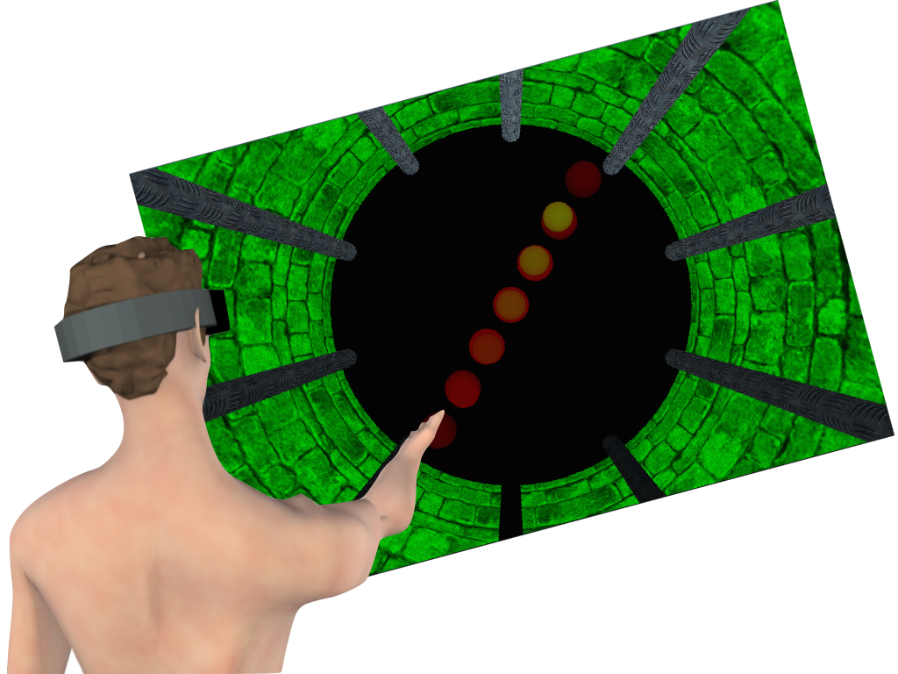

In the menus to the left:

* Choose your User ID.
* Select a posture and then a protocol.
* Use the windows and buttons at the right to execute each task in order.

**Visual-Visual**

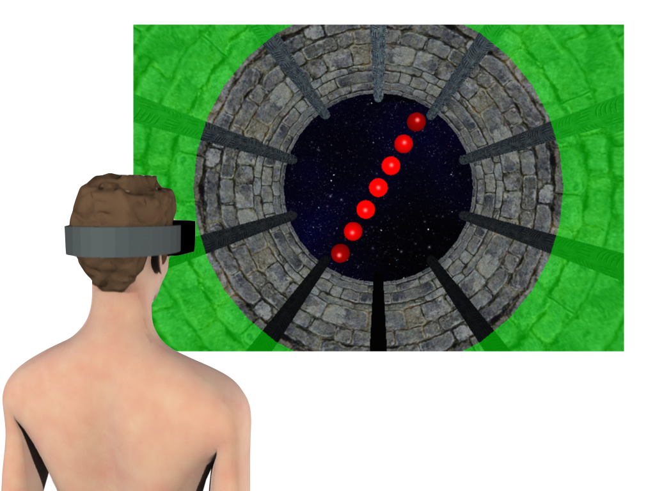

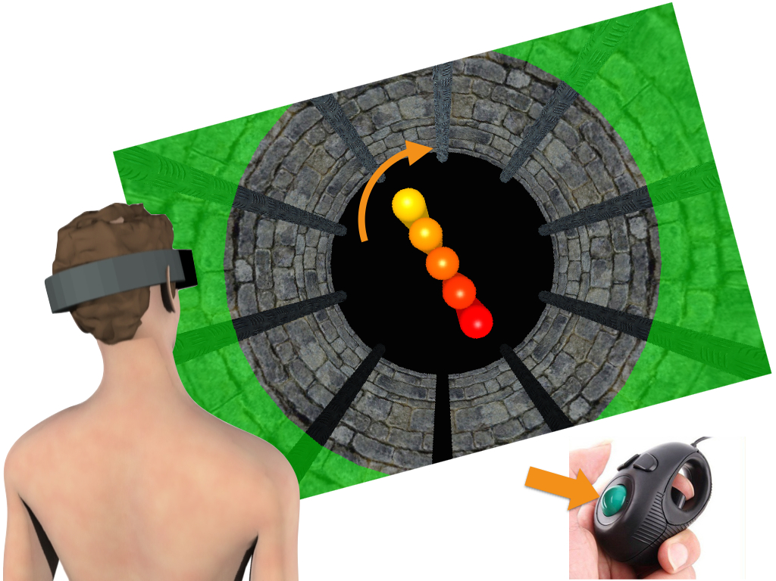

Press **'Next'** to begin.

**Visual-Manual**



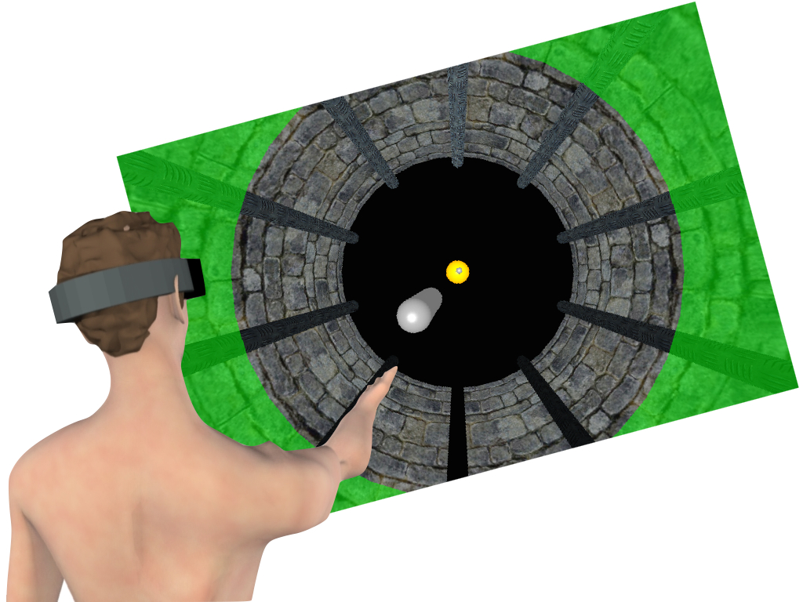

Press **'Next'** to begin.

**Manual-Manual**

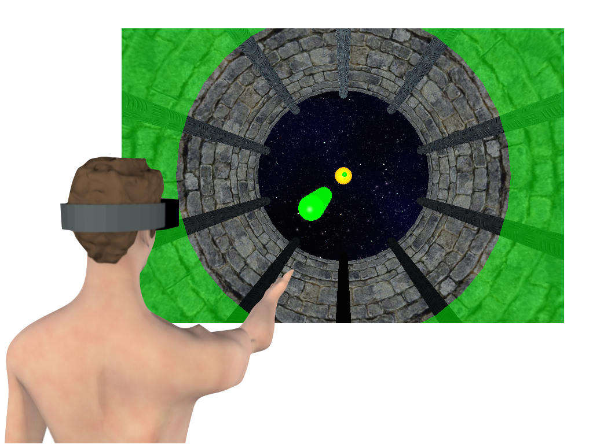



Press **'Next'** to continue.

**Tracker Alignment**

Ready to perform the alignment procedure for the 3D tracker:

* Verify that the equipment is installed as shown:

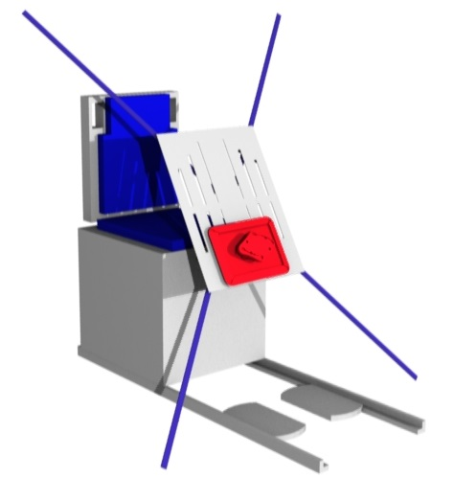

* Check that the field of view of the tracker cameras is free of obstructions.
* Confirm that the chest markers are positioned properly on the chair.

Press **'Execute'** to perform alignment.

**Tracker Alignment**

Ready to perform the alignment procedure for the 3D tracker:

* Verify that the equipment is installed as shown:

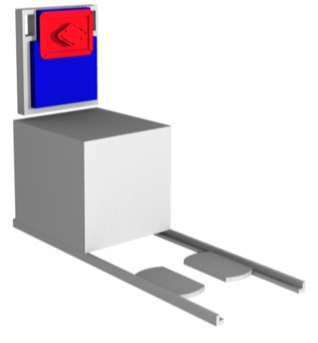

* Check that the field of view of the tracker cameras is free of obstructions.
* Confirm that the chest markers are positioned properly on the chair.

Press **'Execute'** to perform alignment.

**Ready to Start**

Adopt the seated posture with chest and hand markers attached and the HMD ready.

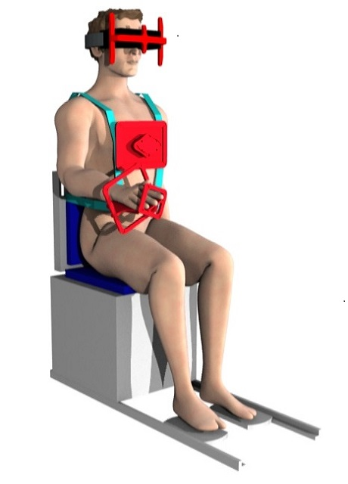

Press **'Execute'** then don HMD and start trials.

**Ready to Start**

Adopt the quasi-freefloating posture with chest and hand markers attached and the HMD ready.

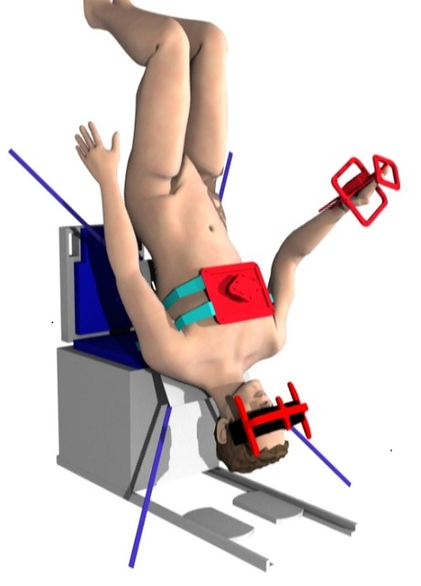

Press **'Execute'** then don HMD and start trials.

***Step 1: Straighten Head***

* If your head is laterally tilted with respect to the trunk, the halo will be red.

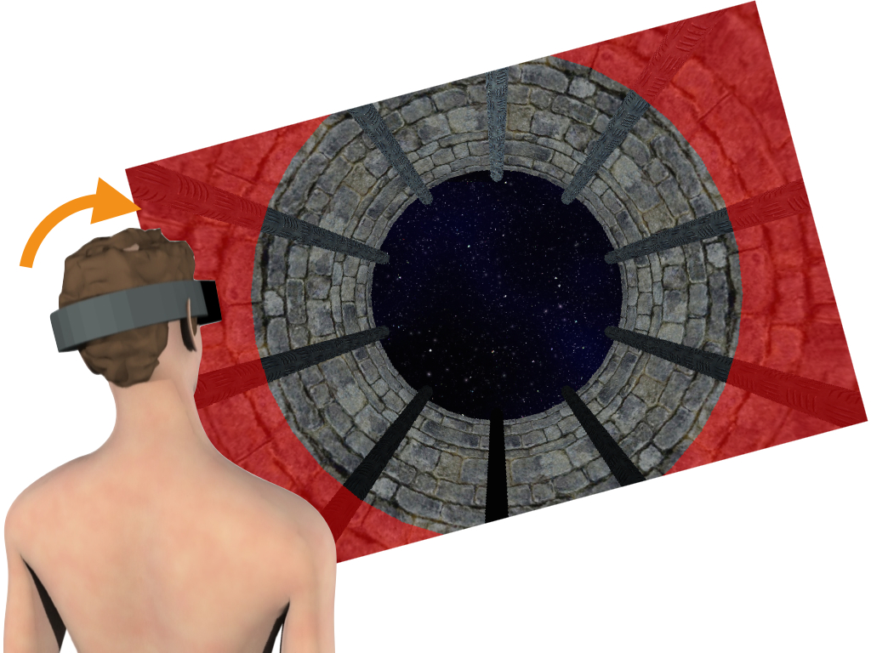

* Align the head to your body axis, this will make the halo turn bright green.

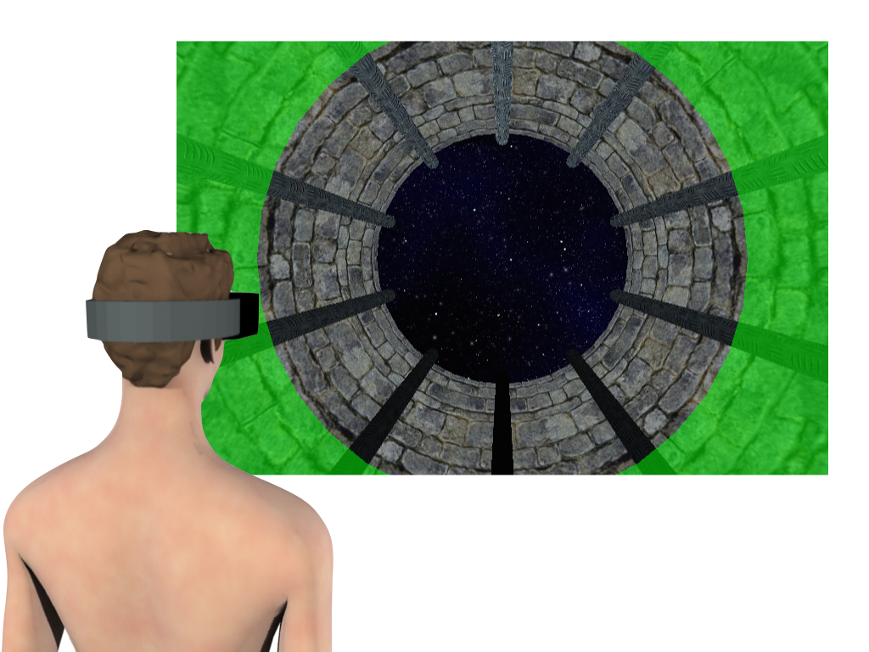

***Step 2: Acquire Target***

* Once your head is aligned with your body, a disk-shaped target will appear. Raise your arm and point until the laser-pointer falls on the target.

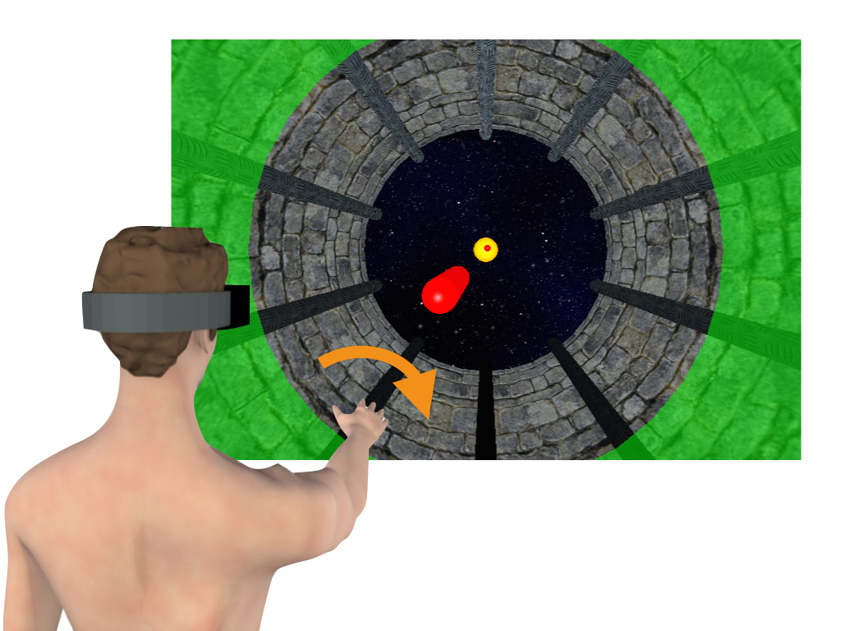

* Rotate your hand in a rolling motion around the axis of your arm until the pointer and the tool turn bright green. Memorise the corresponding hand orientation.



* When the target dissappears, lower your arm to your side.

***Step 2: Acquire Target***

* Once your head is aligned with your body (i.e. when the halo is bright green), a line of balls will appear at the end of the tunnel, representing the target orientation.



* Memorise the target orientation.

***Step 3: Tilt the Head***

* If the tunnel turns red, you must tilt you head to a new orientation. If an arrow appears, it tells you which way to rotate the head.

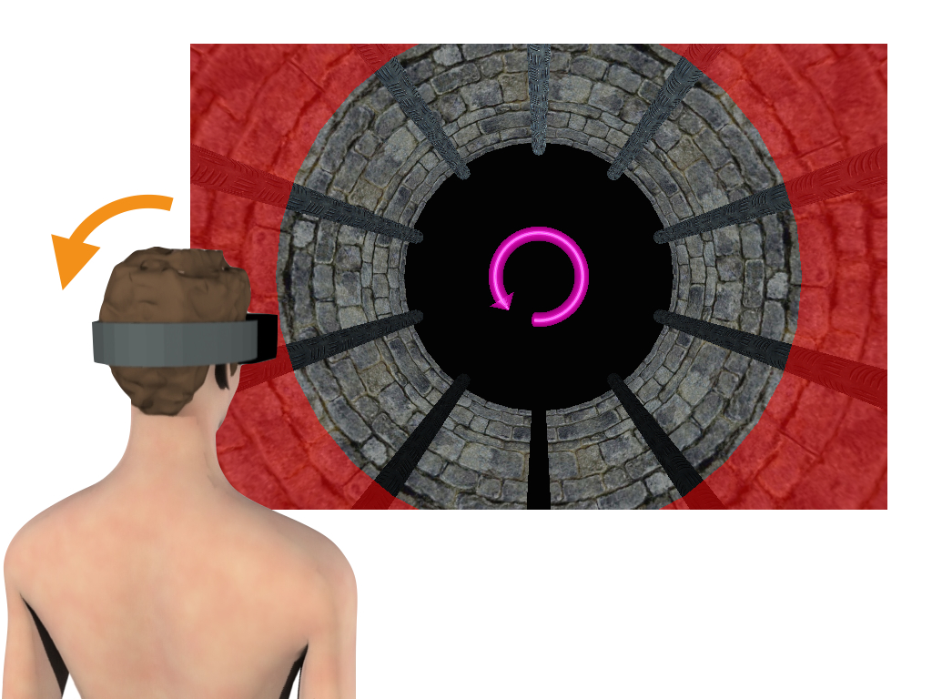

* Roll your head from side to side until the tunnel turns green.

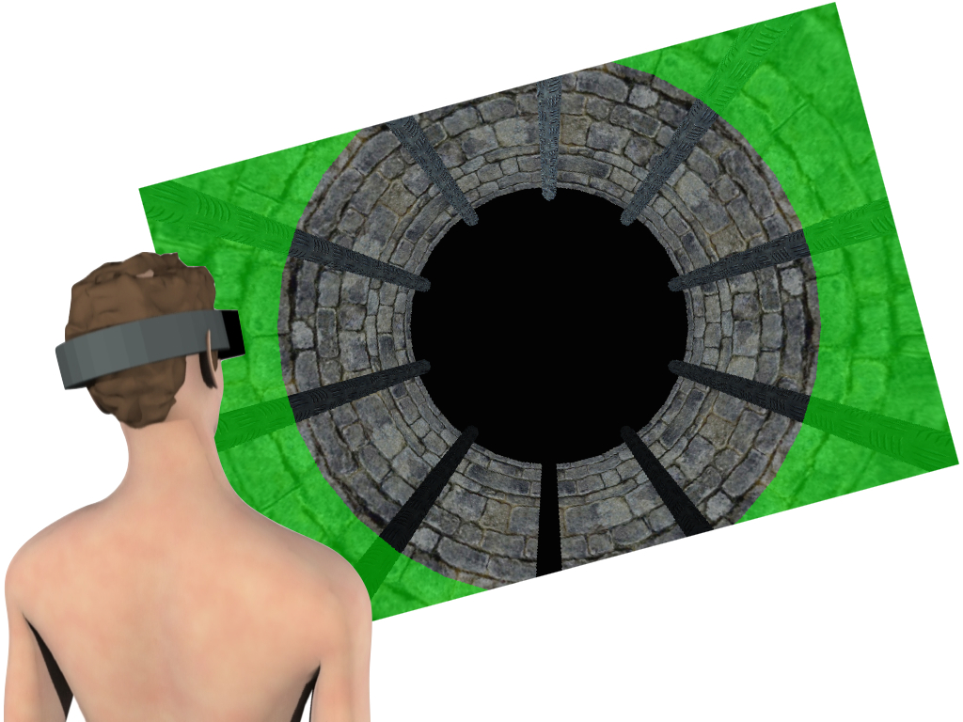

* Hold this position.

***Step 4: Align to Target***

* When the orange disk reappears, raise your arm and aim until the laser pointer falls on the disk.
* Rotate your hand in a rolling motion around the axis of your arm to the remembered target orientation. The hand will not change color.

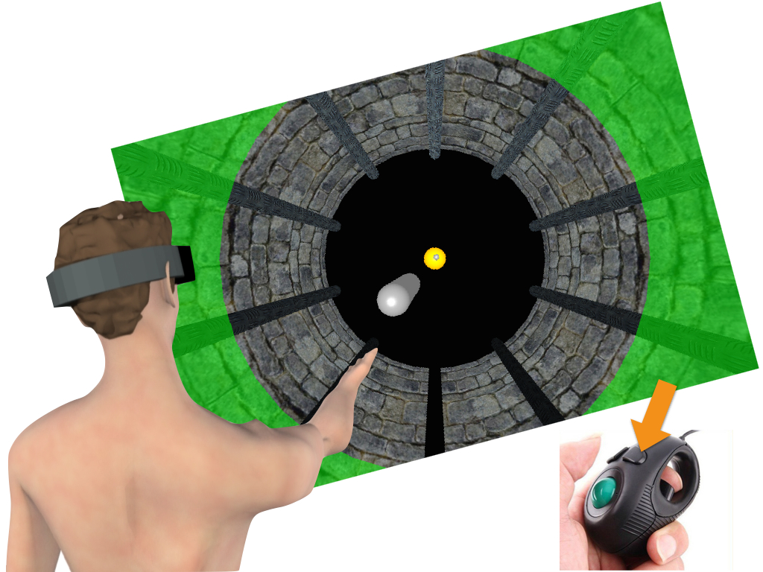

* Click on the top right mouse button to validate your response once you think your hand is aligned with the memorised target.

***Step 4: Align to Target***

* Use the mouse trackball to align the tool to the memorised target (trackball movements to the left and right produce counterclockwise and clockwise rotations of the tool, respectively).



* Click on the right mouse button to validate your response once you think that your hand is aligned with the memorised target.

***Step 5: Check Response***

* In some of the trials a line of target balls will be projected from your hand towards the targets, allowing you to verify whether or not you correctly aligned your hand.

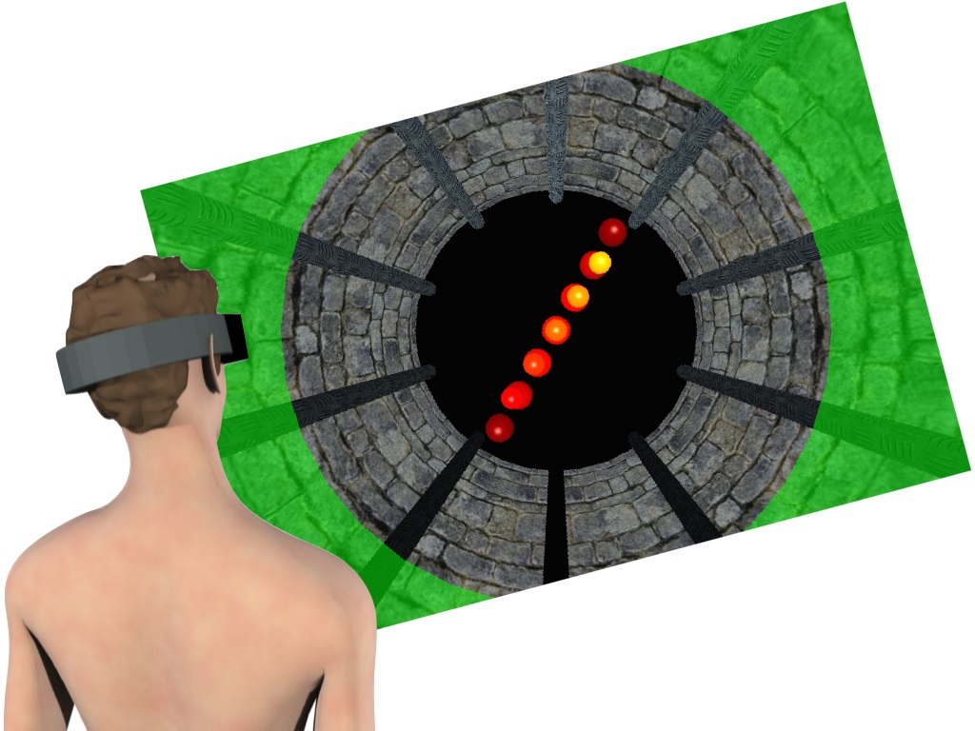

**Ready to Start**



Press **'Execute'** to continue.

**Application Running**



**Action Terminated**



If normal exit:

* **'Next'** to continue to next step.

If error exit:

* **'Retry'** to repeat this action.
* **'Ignore'** to ignore error and move on.
* **'Restart'** to re-initiate this task or select another.

**Recommendation:** Attempt **'Retry'** no more than once or twice before consulting with POCC. **'Ignore'** and **'Restart'** should not be used without POCC autorization.

**Action Completed Normally**



Press **'Next'** to continue.

**Action Completed with Errors**



Press:

* **'Retry'** to repeat this action.
* **'Ignore'** to ignore and move on.
* **'Restart'** to restart this task or select another.

**Recommendation:** Attempt **'Retry'** no more than once or twice before consulting with POCC. **'Ignore'** and **'Restart'** should not be used without POCC autorization.

**Not Yet Implemented**



**Invalid Selection**



**Task Terminated**



Press **'Next'** to proceed.

**Subsession Terminated**



Press **'Next'** to exit.